Module-1
HTML-5
Exercise-1
<!DOCTYPE html>
<html lang="en">
<head>
<meta charset="UTF-8">
<meta name="viewport" content="width=device-width, initial-scale=1.0">
<title>Local Community Event Portal</title>
</head>
<body>
<nav>
<h2>Community Event Portal</h2>
<ul>
<li><a href="#">Home</a></li>
<li><a href="#">Events</a></li>
<li><a href="#">Services</a></li>
<li><a href="#">Contact</a></li>
</ul>
</nav>
<main>
<h1>Welcome to the Local Community Event Portal</h1>
<p>Find events, register online, and access local services.</p>
</main>

<footer>
<p>&copy; 2026 Local City Council. All Rights Reserved.</p>
</footer>
</body>
</html>
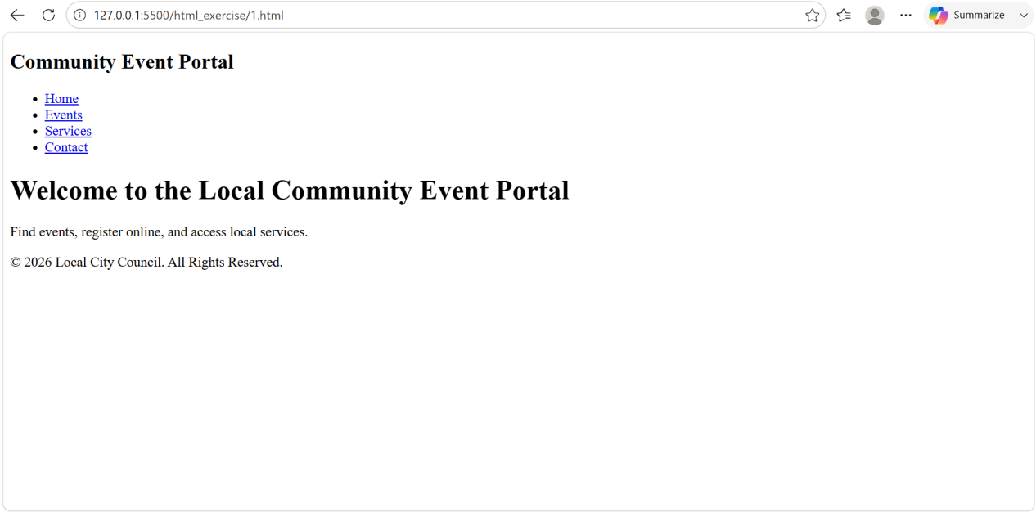

Exercise-2

<!DOCTYPE html>
<html lang="en">
<head>
<meta charset="UTF-8">
<meta name="viewport" content="width=device-width, initial-scale=1.0">
<title>Community Event Portal</title>
</head>
<body>

<nav>
<a href="#home">Home</a> |
<a href="#events">Events</a> |
<a href="#contact">Contact</a> |
<a href="help.html" target="_blank">Help</a>
</nav>

<section id="home">
<h2>Home</h2>
<p>Welcome to the Community Event Portal.</p>
</section>

<section id="events">
<h2>Events</h2>
<p>Check upcoming community events here.</p>
</section>

<section id="contact">
<h2>Contact</h2>
<p>Contact us for more information.</p>
</section>

</body>
</html>
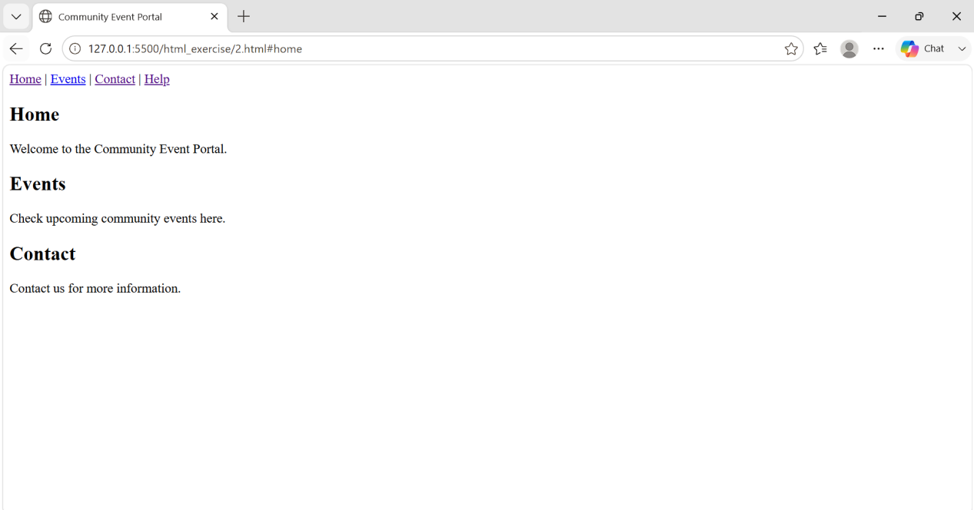

Exercise-3

<!DOCTYPE html>
<html lang="en">
<head>
<meta charset="UTF-8">
<title>Welcome Banner</title>

<style>
#welcomeBanner {
background-color: blue;
color: white;
padding: 15px;
text-align: center;
}

.highlight {
background-color: yellow;
font-weight: bold;
}
</style>
</head>
<body>
<div id="welcomeBanner">
<h2>Welcome, User!</h2>
<p class="highlight">You have successfully logged in.</p>
<p>
Special Offer:
<span style="color: red; font-weight: bold;">
Get 20% off on event registration!
</span>
</p>
</div>
<p class="highlight">Don't miss the upcoming community events.</p>
</body>
</html>

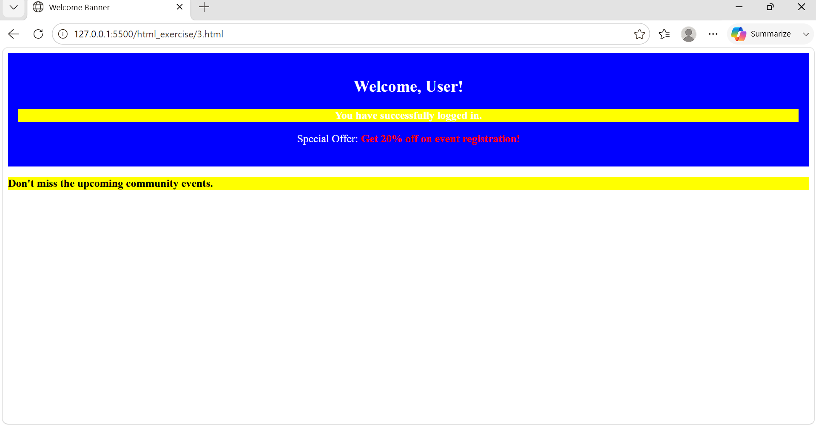
Exercise-4

<html>
<head>
<title>Community Event Gallery</title>
<style>
.event-img {
border: 2px solid black;
}
</style>
</head>
<body>

<h2>Community Event Gallery</h2>

<table border="1">
<tr>
<td>
<img src="event1.jpg" alt="Tree Plantation Drive" title="Tree Plantation Drive" class="event-img" width="200" height="150">
<br>Tree Plantation Drive
</td>
<td>
<img src="event2.jpg" alt="Health Camp" title="Health Camp" class="event-img" width="200" height="150">
<br>Health Camp
</td>
<td>
<img src="event3.jpg" alt="Cultural Festival" title="Cultural Festival" class="event-img" width="200" height="150">
<br>Cultural Festival
</td>
</tr>

<tr>
<td>
<img src="event4.jpg" alt="Sports Meet" title="Sports Meet" class="event-img" width="200" height="150">
<br>Sports Meet
</td>
<td>
<img src="event5.jpg" alt="Blood Donation Camp" title="Blood Donation Camp" class="event-img" width="200" height="150">
<br>Blood Donation Camp
</td>
<td>
<img src="event6.jpg" alt="Community Gathering" title="Community Gathering" class="event-img" width="200" height="150">
<br>Community Gathering
</td>
</tr>
</table>

</body>
</html>
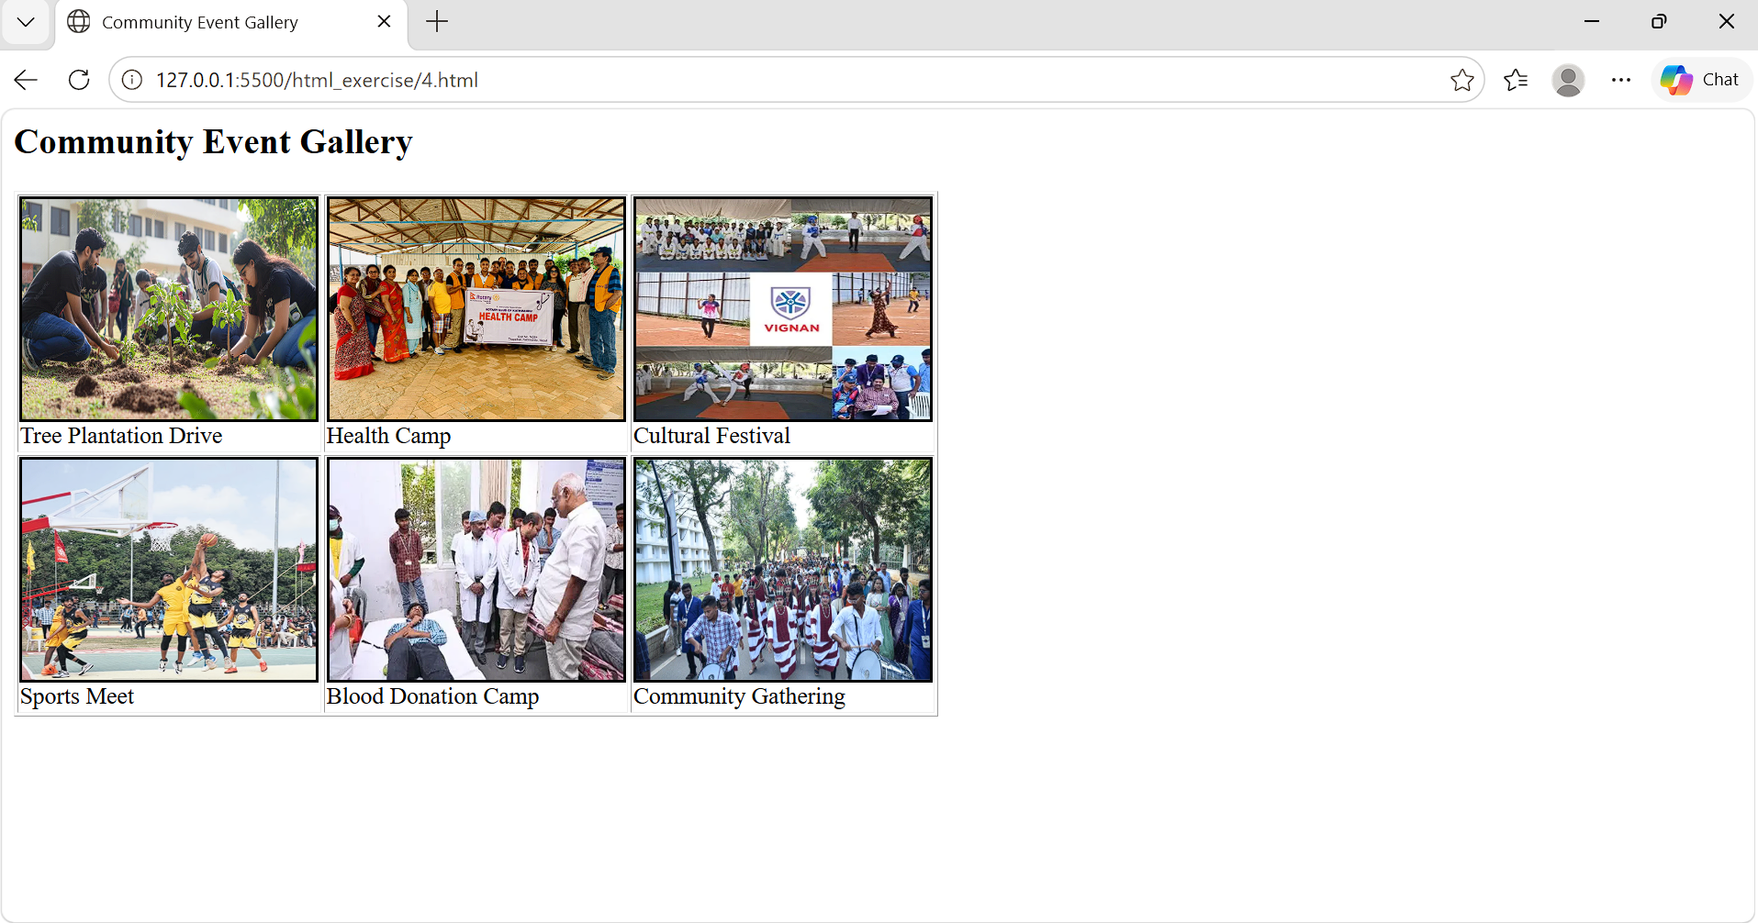

Exercise-5

<html>
<head>
<title>Event Registration Form</title>
<style>
form {
width: 400px;
margin: auto;
padding: 20px;
border: 1px solid black;
background-color: #f2f2f2;
}
input, select, textarea {
width: 100%;
margin: 8px 0;
padding: 8px;
}
button {
width: 100%;
padding: 10px;
background-color: green;
color: white;
}
</style>
</head>
<body>
<h2>Event Registration Form</h2>
<form onsubmit="document.getElementById('result').value='Registration Successful!';return false;">
<label>Name</label>
<input type="text" placeholder="Enter your name" required autofocus>
<label>Email</label>
<input type="email" placeholder="Enter your email" required>
<label>Date</label>
<input type="date" required>
<label>Event Type</label>
<select required>
<option value="">Select Event</option>
<option>Tree Plantation</option>
<option>Health Camp</option>
<option>Cultural Festival</option>
</select>
<label>Message</label>
<textarea placeholder="Enter your message" required></textarea>
<button type="submit">Register</button>
</form>
<output id="result"></output>
</body>
</html>
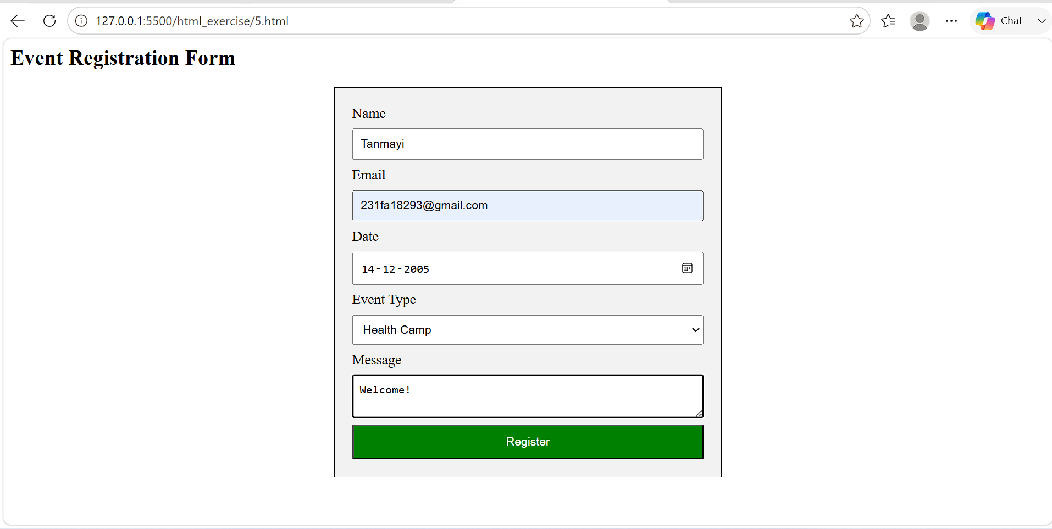
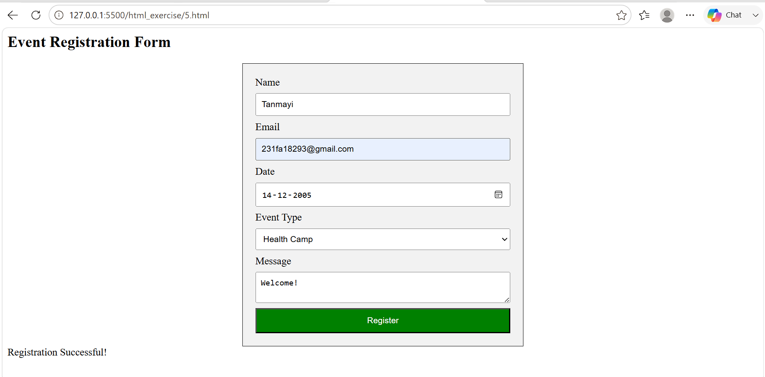

Exercise-6

<html>
<head>
<title>Event Feedback Form</title>
<style>
form {
width: 400px;
margin: auto;
padding: 20px;
border: 1px solid black;
background-color: #f2f2f2;
}
input, select, textarea {
width: 100%;
padding: 8px;
margin: 8px 0;
}
#imgBox {
width: 150px;
transition: 0.3s;
}
#imgBox.big {
width: 300px;
}
#msg {
color: green;
font-weight: bold;
}
</style>

<script>
function validatePhone() {
let phone = document.getElementById("phone").value;
if (phone.length != 10 || isNaN(phone)) {
alert("Enter valid 10-digit phone number");
}
}

function showFee() {
let event = document.getElementById("event").value;
let fee = document.getElementById("fee");

if (event == "tree") fee.innerHTML = "Fee: 100";
else if (event == "health") fee.innerHTML = "Fee: 200";
else if (event == "cultural") fee.innerHTML = "Fee: 300";
}

function confirmSubmit() {
document.getElementById("msg").innerHTML = "Form Submitted Successfully!";
}

function enlargeImage() {
let img = document.getElementById("imgBox");
img.classList.toggle("big");
}

function countChars() {
let text = document.getElementById("feedback").value;
document.getElementById("count").innerHTML = text.length;
}
</script>
</head>
<body>
<form>
<h2>Event Feedback</h2>
<label>Phone Number</label>
<input type="text" id="phone" onblur="validatePhone()" placeholder="Enter phone number">
<label>Select Event</label>
<select id="event" onchange="showFee()">
<option value="">Choose</option>
<option value="tree">Tree Plantation</option>
<option value="health">Health Camp</option>
<option value="cultural">Cultural Event</option>
</select>
<p id="fee">Fee: </p>
<label>Feedback</label>
<textarea id="feedback" onkeyup="countChars()" placeholder="Write feedback"></textarea>
<p>Characters: <span id="count">0</span></p>
<imgsrc="event.jpg" id="imgBox" ondblclick="enlargeImage()" alt="Event Image">
<button type="button" onclick="confirmSubmit()">Submit</button>
<p id="msg"></p>
</form>
</body>
</html>
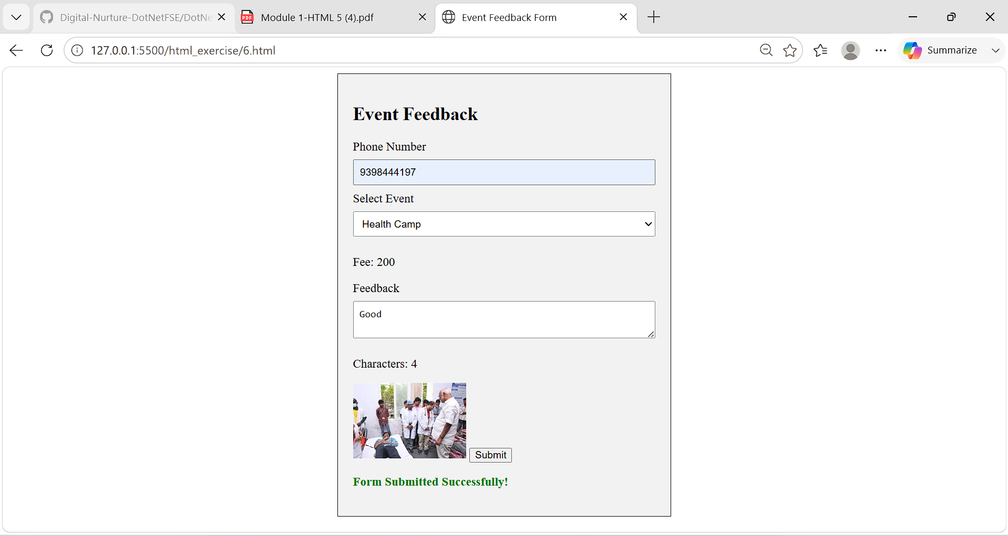

Excercise-7

<html>
<head>
<title>Event Video Invite</title>
<style>
#msg {
color: green;
font-weight: bold;
}
</style>

<script>
function videoReady() {
document.getElementById("msg").innerHTML = "Video ready to play";
}

window.onbeforeunload = function () {
return "You have an unfinished form. Are you sure you want to leave?";
};
</script>
</head>

<body>
<h2>Event Promo Video</h2>

<video width="400" controls oncanplay="videoReady()">
<source src="event.mp4" type="video/mp4">
Your browser does not support video tag.
</video>

<p id="msg"></p>

<form>
<h3>Quick Registration</h3>
<input type="text" placeholder="Name">
<input type="email" placeholder="Email">
<button type="submit">Submit</button>
</form>
</body>
</html>
